**UNITED STATES AIR FORCE ACADEMY DEPARTMENT OF ELECTRICAL AND COMPUTER ENGINEERING**

**ECE 332 Laboratory Exercise 7d**

**RLC Circuit Design**

***C3C’s Mark Demore and Luke McFadden***

**1. Objective**

*State the objectives of the lab.*

**2. Specifications and Limitations**

*Define exactly what your design is supposed to.*

**3. General Approach**

*Discuss how you plan to go from the given specifications to the final build.*

**4. Design**

**a. Mathematical Equation**

*Discuss the theory behind the response of an RLC circuit, including the governing equations. Include in this section a graph of your theoretical circuit response.*

*Note you might want to include the different data points on your graphs.*

3.5

|  |  |  |  |  |  |  |
| --- | --- | --- | --- | --- | --- | --- |
|  |  |  |  |  |  |  |
|  |  |  |  |  |  |  |
|  |  |  |  |  |  |  |
|  |  |  |  |  |  |  |
|  |  |  |  |  |  |  |
|  |  |  |  |  |  |  |
|  |  |  |  |  |  |  |

Theoretical Circuit Response

3

2.5

2

v (t), V

1.5

c

1

0.5

0

0 0.1 0.2 0.3 0.4 0.5 0.6 0.7

t, ms

**Figure 1. Theoretical Response**

*Use the waveform to determine if your equation meets the specifications (it should.)*

**b. Circuit Simulation**

*Discuss how you came up with your circuit values. Include all relevant equations and any assumptions. Include a graph that includes both the graph from Figure 1 and the Multisim graph (shown below)*

Theoretical and Simulated Circuit Responses

4

3.5

3

2.5

2

v (t), V

c

1.5

1

0.5

0

0 0.05 0.1 0.15 0.2 0.25 0.3 0.35 0.4 0.45 0.5

|  |  |  |  |  |  |  |  |  |  |  |
| --- | --- | --- | --- | --- | --- | --- | --- | --- | --- | --- |
|  |  |  |  |  |  |  |  |  |  | |
| Multisim  Theoretical | | |  |
|  |  |  |  |  |  |  |  |
|  |  |  | |
|  |  |  |  |  |  |  |  |  |  | |
|  |  |  |  |  |  |  |  |  |  | |
|  |  |  |  |  |  |  |  |  |  | |
|  |  |  |  |  |  |  |  |  |  | |
|  |  |  |  |  |  |  |  |  |  | |
|  |  |  |  |  |  |  |  |  |  | |

t, ms

**Figure 2. Simulated Circuit Results**

**c. Realistic Values**

*State how you came up with the realistic values. Include all three graphs on the same plot, as shown below.*

Theoretical and Simulated Circuit Responses

4

3.5

3

2.5

2

v (t), V

c

1.5

1

0.5

0

|  |  |  |  |  |  |  |  |  |  |  |
| --- | --- | --- | --- | --- | --- | --- | --- | --- | --- | --- |
|  |  |  |  |  |  |  |  | |  |  |
|  | Multisim  Theoretical  Realistic | | |
|  |  |  |  |  |  |  |  | |  |  |
|  |  |  |  |  |  |  |  | |  |  |
|  |  |  |  |  |  |  |  | |  |  |
|  |  |  |  |  |  |  |  | |  |  |
|  |  |  |  |  |  |  |  | |  |  |
|  |  |  |  |  |  |  |  | |  |  |
|  |  |  |  |  |  |  |  | |  |  |

0 0.05 0.1 0.15 0.2 0.25 0.3 0.35 0.4 0.45 0.5

t, ms

**Figure 3. Theoretical, Ideal, and Realistic Responses**

*Ensure your realistic simulation meets your specifications. Include an error analysis to prove it.*

**Table 1. Percent Error Using Realistic Values.**

|  |  |  |  |
| --- | --- | --- | --- |
| Parameter | Ideal Value | Realistic Value | Percent Error |
| ζ |  |  |  |
| 𝑓𝑓0 |  |  |  |
| v(∞) |  |  |  |

**5. Implementation**

*Talk about building your circuit. Include relevant schematics and any type of measurements you performed to determine parasitic values.*

**Figure 4. Circuit Model**

**(Include a schematic of your final design) Figure 5. Schematic**

Include photographs of your actual circuit.

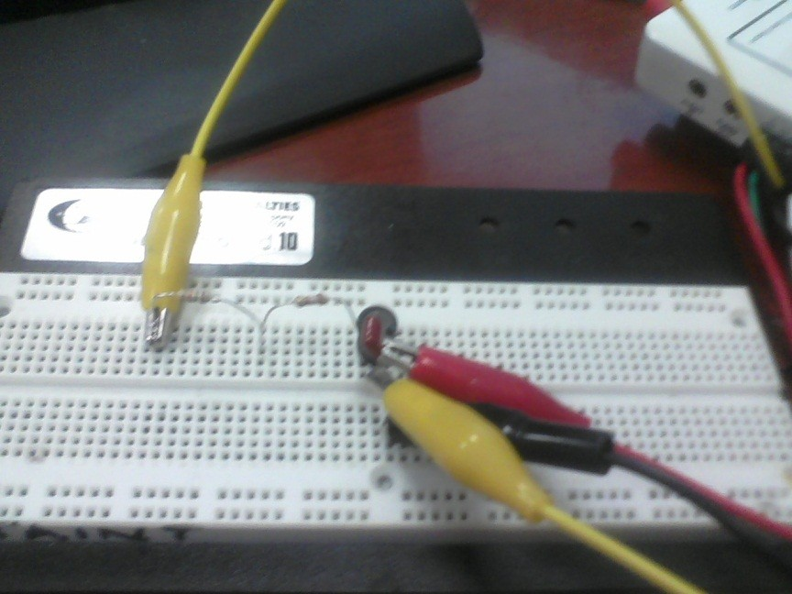

**Figure 6. myDAQ Circuit**

**6. Analysis and Testing**

*Talk about how you tested your circuit. You can include screen captures from the myDAQ instruments. However, you will want to include the myDAQ results and the Multisim results on the same graph, as shown below.*

Multisim and myDAQ Circuit Responses

4

3.5

3

2.5

2

v (t), V

c

1.5

1

0.5

0

0 0.05 0.1 0.15 0.2 0.25 0.3 0.35 0.4

|  |  |  |  |  |  |  |  |  |
| --- | --- | --- | --- | --- | --- | --- | --- | --- |
|  |  |  |  |  |  |  |  | |
| Multisim myDAQ | |  |
|  |  |  |  |  |  |  |
|  |  | |
|  |  |  |  |  |  |  |  | |
|  |  |  |  |  |  |  |  | |
|  |  |  |  |  |  |  |  | |
|  |  |  |  |  |  |  |  | |
|  |  |  |  |  |  |  |  | |
|  |  |  |  |  |  |  |  | |

t, ms

**Figure 7. Built Circuit Response.**

*Measure the myDAQ data (whether it be in Matlab or using the cursors on the scope). Perform an error analysis.*

|  |  |  |  |  |  |
| --- | --- | --- | --- | --- | --- |
| **Parameter** | **Ideal**  **Value** | **Designed-to**  **Value** | **Built Value** | **Percent Error**  **Specified Values** | **Percent Error**  **Designed Values** |
| ζ |  |  |  |  |  |
| fo |  |  |  |  |  |
| v(∞) |  |  |  |  |  |

**Table 2. Percent Error of Realized Circuit.**

*Perhaps include possible sources of error*

|  |  |  |  |
| --- | --- | --- | --- |
| **Device** | **Component Value** | **Measured Value** | **% Difference** |
| Inductor |  |  |  |
| Capacitor |  |  |  |
| Resistor |  |  |  |
| Resistor |  |  |  |

**Table 3. Actual Component Values**

*For some final analysis, you should graph the theoretical response USING YOUR MEASURED COMPONENT VALUES and plot against your measured response. Sometimes they match up, sometimes they do not.*

**5. Conclusions**

*Summarize your design's performance, lessons learned, etc.*

**Appendices**

*Include any Matlab code—I don't need everything. Basic code used to generate plots is fine.*